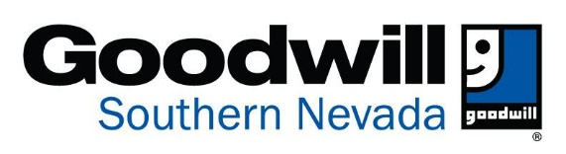
IF FORM IS ISSUED BY STORE:
Date/Time:

Manager:

UNINTENTIONAL DONATION REPORT

Thank you for alerting us of an unintended donation. We make every attempt to verify, locate, and return merchandise that is unintentionally donated to Goodwill. Please understand that despite our best efforts, we are often unable to recover such items due to the large volume of donated goods we receive and process each day, or the length of time since the donation was made.

This form must be completed by the person who made the unintended donation. To improve our chances of locating the item(s), please provide as much information as possible when answering the questions below. We will contact you once we have completed our thorough investigation.

Name:
Address: Date:
Email Address:
Phone: Secondary Phone (if applicable:

Describe the item(s) that were donated unintentionally:

Describe any other items that were donated with the unintentionally donated item(s):

If applicable, describe the container used to donate the item(s):

If currency was unintentionally donated, describe the exact amount and denominations:

Donation Date/Time:
Donation Location:
If items were donated at drive-thru, vehicle make and color:
Description of Donation Attendant:
Do you have a donation receipt? Yes No

Item found & returned to Donor? Yes No Manager Approval: Date:

